Name; Oyenuga Mustapha Opeyemi
Matric Number; 15\EN06/061

INTRODUCTION
With the recent corona virus outbreak, leading to the increase in demand and the resultant shortage of hand sanitizers worldwide, the industry is currently witnessing manufacturers from other industries using their production expertise and facilities to contribute to hand sanitizer manufacturing to help mitigate the supply shortage. Will this help meet the rapid surge in demand worldwide? Our team is working to account for this surge in our estimates. The report will account for Covid19 as a key market contributor.

The global hand sanitizer market size was valued at USD 2.7 billion in 2019. Shifting consumer preference towards convenient hygiene products is expected to drive the market. In addition, recent COVID-19 pandemic in the beginning of 2020 have spurred the market for hand sanitizer. The demand for hand hygiene products have been exceeding the supply in both online as well as brick and mortar sale channels worldwide owing to the global outbreak of the virus in a short time span. The outbreak has reinforced the significance of regular hand sanitizing and cleaning practices among consumers and is among the prominent factor driving the market.
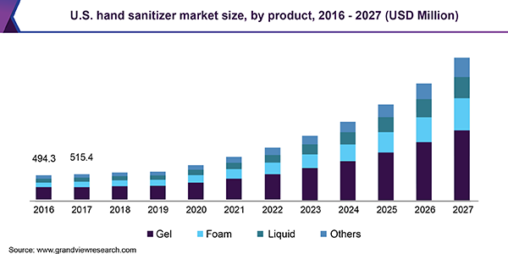
Hand sanitizers have an advantage over conventional hand washing products as they can be applied directly without water. Also, renowned manufacturing companies such as Henkel Corporation, Unilever, and Procter and Gamble have been offering hand sanitizers in convenient packaging such as sachet and mini bottles, which can easily be carried in a bag or a pocket by the consumers. These factors have widened the scope for the market.
According to findings, there is a preference for using hand sanitizer by 77.0% of the population covered in a survey, while 23.0% claim to not to use the product. The 77.0% population in the favor of using hand sanitizer is comprised of 37.5% male users and 62.5% of female users. Moreover, key manufacturers are adding to their product line in order to increase their market share with increasing awareness. For instance, as per findings, 62.0% of population surveyed in 2017 claims to use Dettol hand sanitizer, 21.0% use Lifebuoy hand sanitizer, and 17.0% use Himalaya hand sanitizer.
Increasing awareness towards hand hygiene is gaining prominence on account of being an important measure to restrict the occurrence of nosocomial infections. Therefore, hand hygiene forms the most important element of personal care, thereby driving the popularity of hand sanitizers. In addition, government further promotes the usage of hand care products in order to increase awareness as well as avoid health issues among consumers. For instance, WHO and FDA have taken initiatives in order to make people aware about hand hygiene and the risks associated with not maintaining the hygiene.
Moreover, rising influence of social media and online advertisements have exposed people to the recent trends of personal care and hygiene which is also accelerating the usage of hand sanitizers among consumers. These advertisements also allow people to get exposed to information regarding cleansers and healthy lifestyles. Key companies such as Reckitt Benckiser Group plc and Hindustan Unilever are also leading among consumers with their initiatives on spreading awareness about basic hand hygiene.
Hand sanitizers come across as a beneficial product to consumers in various aspects. The extent to which it is easy to use as well as portable and convenient has made the product popular among consumers. According to studies, this product also minimizes the risk of gastrointestinal and respiratory infections among consumers. Moreover, hand sanitizers also contain ingredients which help in reducing skin dryness and irritation compared to hand washing. Furthermore, according to studies, classroom application of hand sanitizers is expected to reduce absenteeism of students due to illness by 20%. However, growth of the market can be hampered by the usage of chemical ingredients associated with the product causing allergies to some people. While product innovation and new product development strategies adopted by the companies to introduce organic and natural ingredients in the manufacturing of hand sanitizers, which will gain the trust of consumers.

Distribution Channel Insights
Hypermarket and supermarket channel accounted for the largest share of more than 39.3% of the market in 2019. Increasing number of hypermarkets and supermarkets across various regionshave experienced surge in the distribution of hand sanitizers in the market. However, this channel provides the consumers with an advantage of scanning the product before buying which helps them choose the right product. Moreover, this channel also supplies quick access to the product compared to online channels where consumers are made to wait for the delivery of the product.
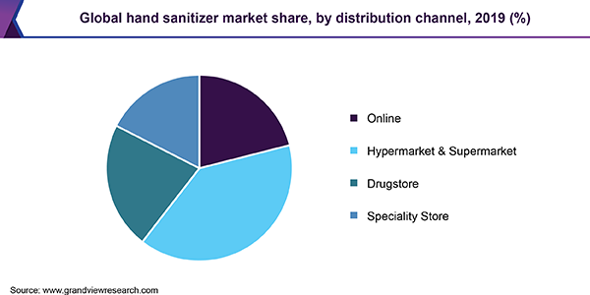
To learn more about this report, request a free sample copy
Online distribution channel is projected to witness a CAGR of 23.2% from 2020 to 2027 owing to increasing influence of digital media and marketing. Increasing internet penetration in various countries such as India, China, Mexico, and Brazil has developed the market for online sales channel from the last three to four years. Moreover, online retailers including Amazon, Walmart, Alibaba and other such service providers are focusing on continuous availability of personal care products across the globe. Online retail channels are widely used in developed countries such as U.S., Germany, and U.K., for purchasing consumer goods and unique personal care products. It is poised to emerge as a steady revenue generating source for these product categories over the forecast period. Promising growth exhibited by e-commerce platforms in emerging countries, including India and China, is compelling manufacturers to reorient their retail strategies for these countries.
Regional Insights
North America dominated the market and accounted for revenue share of 32.2% in 2019. Growing concern for health and hygiene maintenance by majority of the population in the region is expected to drive the market. Wider product availability with increased penetration of online as well as offline channels is driving the growth of the market in the region. This region with greater number of market players’ witnesses’ highest penetration of different forms of hand sanitizers such as gel based, foam based, spray, and wipes. Moreover, U.S. dominates the market with more willingness of consumers to spend on personal care and hygiene products.
Asia Pacific is expected to witness the fastest CAGR of 23.5% from 2020 to 2027. The growth is attributed to the growing awareness about hygiene among consumers. Therefore, innovative and different types of personal care and hygiene products are available in the market stressing on convenience factor for consumers. The increasing dominance of online shopping has reshaped the growth of the market in the region and is expected to fuel the demand for hand sanitizers in the future years. For instance, online websites such as Amazon, Flipkart, Grofers, and other such online delivery service firms are offering different types of hand hygiene products.
Hand Sanitizer Market Share Insights
The market is highly competitive in nature. Top players’ operating in the market are Reckitt Benckiser Group plc; Procter and Gamble; The Himalaya Drug Company; GOJO Industries, Inc.; Henkel AG and Company; Unilever; Vi-Jon; Chattem, Inc.; Best Sanitizers, Inc.; and Kutol. Companies are focusing on expanding their production capacity and are adopting innovative technologies to meet consumer demand for hand sanitizers.
Report Scope
Attribute | Details
Base year for estimation | 2019
Actual estimates/Historical data | 2016 - 2018
Forecast period | 2020 - 2027
Market representation | Revenue in USD Million & CAGR from 2019 to 2025
Regional scope | North America, Europe, Asia Pacific, Central & South America, Middle East & Africa
Report coverage | Revenue forecast, company share, competitive landscape, growth factors and trends
Country Scope | U.S., Germany, U.K, India, China, Brazil
15% free customization scope (equivalent to 5 analyst working days) | If you need specific information, which is not currently within the scope of the report, we will provide it to you as a part of customization
Segments Covered in the Report
This report forecasts revenue growth at global, regional, and country levels and provides an analysis of the latest industry trends in each of the sub-segments from 2016 to 2027. For the purpose of this study, Grand View Research has segmented the global hand sanitizer market report on the basis of product, distribution channel, and region:
- Product Outlook (Revenue, USD Million, 2016 - 2027)
  - Gel
  - Foam
  - Liquid
  - Others
- Distribution Channel Outlook (Revenue, USD Million, 2016 - 2027)
  - Hypermarket & Supermarket
  - Specialty Store
  - Drugs Store
  - Online
- Regional Outlook (Revenue, USD Million, 2016 - 2027)
  - North America
    - U.S.
  - Europe
    - Germany
    - U.K
  - Asia Pacific
    - China
    - India
  - Central & South America
    - Brazil
  - Middle East & Africa

Industry trends
Hand Sanitizer Market size was USD 1.2 billion in 2019 and will witness a CAGR of -2.4% between 2020 and 2026. The novel strain, SARS-COV-2, that has not previously been seen in humans until late 2019, causes coronavirus COVID-19 infection. The COVID-19 outbreak was firstly seen in Wuhan province of China and within a short span of just four months, the COVID-19 spread drastically and took over the entire world. The severe pandemic, COVID-19, is known for its rapid transmissibility.
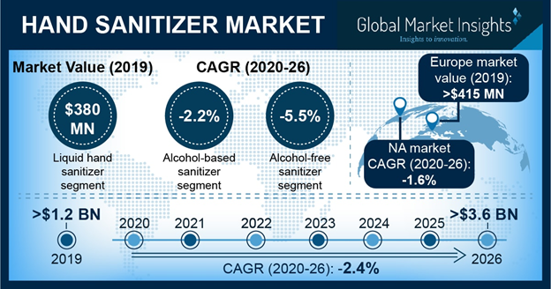
Get more details on this report - Request Free Sample PDF
This has significantly impacted consumer behaviour to take more preventive measures regarding personal hygiene, especially hand hygiene. People are being advised through advertisements and news to use hand sanitizer often as one may get contracted with the infection unknowingly. This is anticipated to significantly boost the market growth. Due to COVID-19 pandemic, the market is expected to witness 244% year-on-year growth in 2020 over 2019.
Hand Sanitizer Market Report Coverage
Report Coverage | Details
Base Year: | 2019 | Market Size in 2019: | 1,239.2 Million (USD)
Historical Data for: | 2015 to 2019 | Forecast Period: | 2020 to 2026
Forecast Period 2020 to 2026 CAGR: | -2.4% | 2026 Value Projection: | 3,685.3 Million (USD)
Pages: | 80 | Tables, Charts & Figures: | 150
Geographies covered (34): | U.S., Canada, Germany, UK, France, Italy, Spain, Austria, Sweden, Norway, Denmark, Poland, Switzerland, Netherlands, Turkey, Russia, Japan, China, India, Australia, Malaysia, Thailand, Singapore, South Korea, Mexico, Chile, Brazil, Argentina, South Africa, Saudi Arabia, UAE, Iran, Israel, Qatar
Segments covered: | Type, Composition, Distribution channel and Region
Companies covered (16): | 3M, Bath & Body Works Direct, Best Sanitizer, Certus Medical, Deb Group (S. C. Johnson & Son), Ecolab, Godrej Group, GOJO Industries, Hartmann Group, ITC Limited, Kutol, PZ Cussons, Reckitt Benckiser Group, The Himalaya Drug Company, Unilever, and Vi-Jon
Growth Drivers: | - Increasing cases of COVID-19 infection globally  - Rising public awareness about personal hygiene  - Government initiatives to promote good personal hygiene practice  - Growing distribution of hand sanitizers in various healthcare settings
Pitfalls & Challenges: | - Less effectiveness of alcohol-free hand sanitizer
Request 15% Free Customization on this Report

Government initiatives will accelerate the hand sanitizer industry growth
Government initiatives to promote the use of hand sanitizer will propel the market growth, globally. Looking at the worsening situation of COVID-19 pandemic and its robust transmissible nature, the governments of various countries are providing funds to ramp up hand sanitizer production. This will help the government to cater to the rising demand of hand sanitizer in the market and cope-up with the shortage in some areas.
Additionally, governments are providing easy regulatory passage and permission to new entrants for production of hand sanitizers. Asserting that the utilization of hand sanitizer is one of the best precautionary measures available against the pathogen.
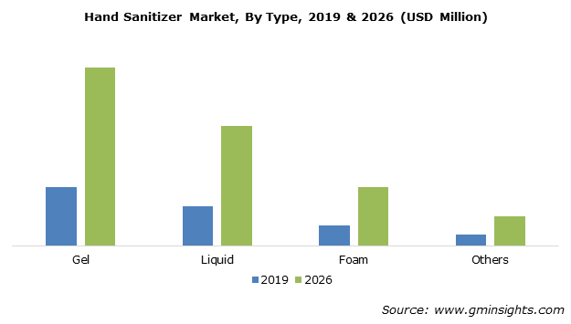
Get more details on this report - Request Free Sample PDF

Inclusion of moisturizers in gel-based hand sanitizer will the drive the market growth
The gel-based hand sanitizer segment is estimated to be valued at around USD 560 million in 2019 and its market will experience a tremendous growth over the forecast period.
Gel-based hand sanitizer is cost-effective and convenient to use. Wide product availability and easy access to gel-based hand sanitizer are propelling the segmental growth. Additionally, inclusion of different fragrance and moisturisers to attract customers will drive the segment growth in the hand sanitizer industry.

Gentle effect of alcohol-free hand sanitizer on skin will drive the market growth
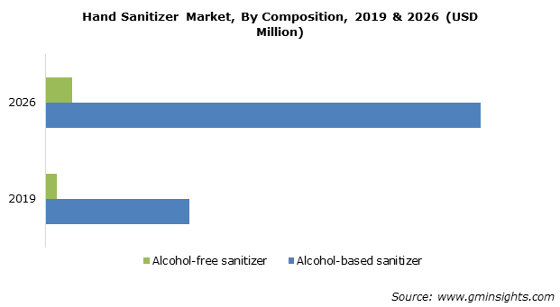
Get more details on this report - Request Free Sample PDF
The alcohol-free sanitizer market will witness around -5.5% CAGR over the forecast period. Alcohol-free hand sanitizer normally contains aloe vera gel or some oil to moisturise dry hands and help maintain soft skin condition.
However, the growth of alcohol-free hand sanitizer is limited due to incapability of killing germs, bacteria and viruses. Though, some alcohol-free hand sanitizer shows good results but the WHO and CDC highly recommends the use of alcohol-based hand sanitizer. This will curb the alcohol-free hand sanitizer segment growth in the forecast period.

Retail distribution channel will drive the market growth
The retail segment is valued more than USD 980 million in 2019. This is attributable to the easy accessibility and availability of consumer goods including hand sanitizer in neighbourhood stores.
The retail distribution channel is further segmented into pharmaceutical stores, supermarkets, convenience stores, and others. Pharmaceutical stores will garner a significant amount of market share due to the availability of hand rubs used by both general public as well as healthcare professionals.

Strong foothold of market players in North America proves beneficial for the regional market
North America hand sanitizer market is expected to hold a substantial revenue share in 2019 and will witness around -1.6% CAGR during the projected timeline. Regional growth is majorly owed to strong foothold of hand sanitizer manufacturers in the region.
Moreover, rising healthcare expenditure and increasing incidences of COVID-19 will foster the market growth over the foreseeable years. Also, high awareness existing among consumers about personal hygiene products will further drive the segmental growth.

Prominent industry players operating in the market focus on catering the high demand for hand sanitizer
Some of the notable industry participants operating in the hand sanitizer market share include 3M, Bath & Body Works Direct, Best Sanitizer, Certus Medical, Deb Group (S. C. Johnson & Son), Ecolab, Godrej Group, GOJO Industries, Hartmann Group, ITC Limited, Kutol, PZ Cussons, Reckitt Benckiser Group, The Himalaya Drug Company, Unilever, and Vi-Jon. The eminent industry participants are implementing various business strategies to garner more revenue share and sustain market competition.

Some of the recent industry developments:
- In April 2018, Arrow Solutions announced the launch of KR10 Hand Sanitizer, an alcohol-free foam sanitizer designed for frequent use. This helped the company to expand its product portfolio and grow in the industry.
- In 2020, Dettol, a brand of Reckitt Benckiser Group plc., pledged to provide around 150,000 care packages to National Health Service (NHS) workers, UK. This will help the company to bring goodwill for the brand recognition.
The hand sanitizer industry research report includes an in-depth coverage of the industry with estimates & forecast in terms of revenue in USD from 2015 to 2026, for the following segments:

Hand Sanitizer Market Overview:
The Global Hand Sanitizer Market size was valued at $919 million in 2016 to reach $1,755 million by 2023, and is anticipated to grow at a CAGR of 9.9% from 2017 to 2023. Hand sanitizer is an antiseptic solution, which is used as an alternative to soap and water. It is used to prevent the transmission of infection, which is majorly caused through hand transmission, further causing several diseases such as nosocomial food-borne illness and others.
Consumer inclination towards health & wellness and product innovation such as addition of fragrances in formulation of sanitizers are projected to boost the growth of the global hand sanitizer market. Furthermore, improvement in living standards, rise in health expenditure, increase in awareness about hand hygiene, and support from organization such as WHO, FDA, and others towards the need for sanitation augment the demand for hand sanitizers. However, health hazards associated with chemical ingredients are anticipated to hamper the market growth during the forecast period.
The report segments the global hand sanitizer market based on product, distribution channel, end use, and geography. On the basis of product, the market is classified into gel, foam, spray, and others. Gel hand sanitizers accounted for the maximum share in 2016. By distribution channel, it is divided into online store, departmental store, pharmacy store, and others. Depending on end use, it is fragmented into restaurants, schools, hospitals, household purpose, and others. Geographically, it is analyzed across North America, Europe, Asia-Pacific, and LAMEA. In addition, the report highlights various factors that impact the growth of the global hand sanitizer industry, such as key drivers, restraints, growth opportunities, and the role of different key players.
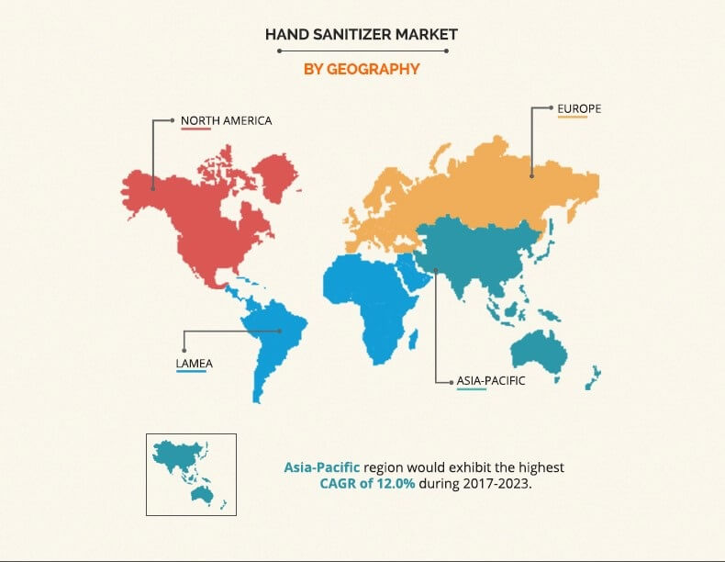
Get more information on this report : Request Sample Pages
North America dominates the global hand sanitizer market, owing to high hygiene standards among the U.S. population. Moreover, Asia-Pacific is expected to witness the highest growth rate from 2017 to 2023, owing to increase in concern towards health and wellness. Furthermore, improvement in living standards and rise in disposable income are expected to boost the growth of the Asia-Pacific hand sanitizer market.
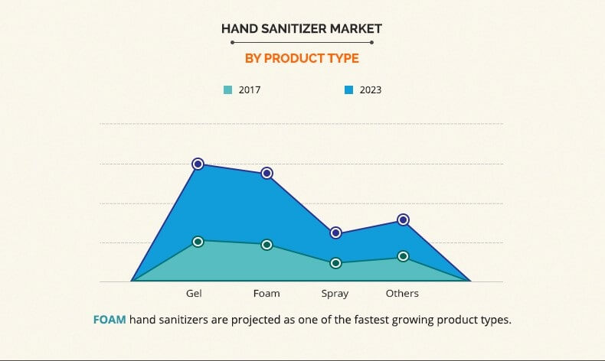
Get more information on this report : Request Sample Pages
Gel-based hand sanitizers generated the maximum revenue in 2016, as they are easily available in the market and require lesser time to effectively eradicate germs as compared to spray and other sanitizers. However, foam-based hand sanitizers are expected to grow at the highest rate, owing to the fact that foam hand sanitizers immediately cling to hands while applying. In addition, foam pumps are relatively smaller than gel or spray pumps, and hence provide a convenient option to the consumers.
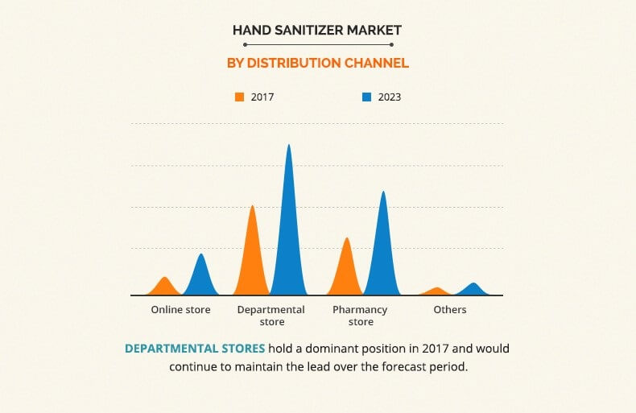
Get more information on this report : Request Sample Pages
Departmental store accounted for the maximum revenue in 2016, as customers prefer to purchase from store such as super markets/hypermarkets. Furthermore, attractive discount policies offered by vendors fuel the growth of departmental stores. However, online store registers the highest growth rate, owing to increase in penetration of mobile phones, rise in e-commerce sales, ease payment options, and attractive discounts as compared to stores.
The key players profiled in the report are Reckitt Benckiser Group, The Himalaya Drug Company, Procter and Gamble, Gojo Industry Inc., Henkel Corporation, Unilever, Vi-Jon Laboratories Inc., Chattem Inc., Best Sanitizers Inc., and Kutol Products Company.
Key Benefits
- This report provides an extensive analysis of the current and emerging market trends and dynamics of the global hand sanitizer market.
- The market trend analysis for all the regions is conducted by constructing estimations for key segments between 2017 and 2023 to identify the prevailing opportunities.
- The report assists to understand the strategies adopted by the leading companies in the industry.
- This study evaluates competitive landscape of the hand sanitizer industry to understand the market scenario globally.
- Extensive analysis is conducted by key player positioning and monitoring the top competitors within the global market.

